TB(2)2

Strategy for the Transparency Division and the Local Public Data Panel

This strategy was first discussed at Local Public Data Panel on 9 September, and will continue to evolve as a living document.

Policy context

Through decentralisation and the Big Society, councils and local people will have more power to build the communities and services they want. Inspection and assessment will be replaced by people holding both local and central government to account more directly. Open data and transparency is a key tool to achieving that, with public bodies aiming to keep private data and other sensitve material very secure and safe, but making everything else both available and visible.

The Panel’s ultimate aim is institutional change within public bodies to ensure a flow of local data to communities to influence local priorities, decisions and actions. The ambition is for councils and other bodies to publish all data except private data. This institutional revolution will happen at different speeds in different places, with an element of learning through mistakes. The market and private sector has an important part to play in driving good practice, as well as the public sector.

Setting government data free will give the public greater insight into what their local authorities are doing and what is happening in their local area. It will also provide significant economic and social benefits by enabling businesses and non-profit organisations to build innovative application and websites. Greater transparency should also lead to opportunities for greater efficiency.

Ensuring all public bodies adopt an effective approach to transparency will require the ‘push’ of guidance or legislation and the ‘pull’ of public demand. The public will need to be made aware of their right to access data and the possibilities for using it in order for them to become ‘citizen auditors’ requesting local data from public bodies and demonstrating real people power in the process.

Government and councils alike will need to learn from best practice wherever that comes from – the Panel will help achieve that learning. Some organisations and councils are blazing a trail in terms of transparency. The Panel will seek to work with the vanguard councils to resolve practical or technical issues and clearly demonstrate the benefits to others. It will also work with communities to understand public demand and uses of data, and to address issues around data literacy. The Panel will also work with the software companies and councils on changing systems and institutional structures, as well as behaviours.

Linked data is an important goal, but the journey will remain of necessity somewhat fluid to allow best practice to evolve and to allow vanguard councils and bodies to chart a pragmatic course which others will follow. Failure in some areas will need to be accepted – indeed welcomed - as part of the journey. The Panel believes this way of solving issues and developing solutions as things develop is the best way of securing real transformation.
Panel ways of working

Over the summer Ministers agreed with the Chair of the Local Public Data Panel that it will effectively be a sub-group of the Public Sector Transparency Board, and feed into the Board’s work.

Full Panel meetings provide an opportunity to debate issues from different perspectives. The Panel will meet every six weeks for the rest of the year, given the pace of developments. This will be reviewed in early spring.

However, a significant contribution will come from sub-groups of the Panel working on a “task and finish” basis around certain issues. These informal groups could be called upon to resolve smaller issues, virtually or through one or two meetings (as happened on the Spotlight on Spend issue).

The Panel will draw on wider expertise on an ad hoc basis around particular issues in a similar way to the Public Sector Transparency Board. As there is no payment for members, only expenses, such expansion is possible within current finances. The Panel will also look to make best use of Communities of Practice already in existence (e.g. 180 councils signed up to the LGA CoP on transparency) to maximise experience and expertise.

Resources

DCLG has set up a new Transparency division for this work, with 9 FTEs (see annex A). This is supported by other officials around the department, including the Geographical and Statistical Evidence Team, the communications team, the policy team on digital services, the FOI team.

The Transparency Division will be able to provide support on a number of fronts, should the Panel wish to work in sub-groups, and also will provide the Panel with better access to key parts of the department, for example the Active Communities division, and Planning policy teams, and plug the Panel into other parts of Whitehall to ensure other important sources of local data are addressed (e.g. crime, health, education).

There is currently some programme money (around £500k) for this financial year available for transparency work should the division or Panel wish to bid for some. However, the department has to make significant in-year savings so this budget cannot be guaranteed until committed. The Panel has already suggested this could be spent on hack days/ developer days (possibly contributing to the Board’s themed series); some work with students on analysing or using data; and a series of events on understanding the basics of local government finance. These opportunities will be developed by working groups.

Policy objectives

The work of the Department and the Panel will be underpinned by the Transparency Principles being worked up by the Public Sector Transparency Board, attached for completeness at annex B.

Delivering transparency and open data is a transformative and ambitious programme. For ease, the Panel has broken it down into three key tasks:

- Ensuring local authorities and other bodies are part of the journey on transparency, complying with the spirit of open data and engaging in dialogue with developers and others about how best to move forward in a process of continuous improvement
- Discussions around how to standardise local authority data (and other local data) and which data should be standardised as a priority
- Capacity building and work on skills and demand, by encouraging citizens, developers, public and private sector organisations to access and use local data and information

Tasks for the Transparency Division, and potentially the Panel, are set out below under those three categories. There are other ways to categorise the work, and there will always be crossover – this is offered as a working model.

Tasks marked with * are ones which are in the DCLG’s Structural Reform Plan (see annex A) and therefore already on Ministers’ radar as commitments to be met in full at the earliest possible date. The Structural Reform Plan is due to be refreshed in October 2010 and Panel’s comments are welcomed on how best to update it, looking for headline goals up to 2 years in the future, and milestones on the way.

Ensuring local authorities and other bodies are part of the journey on local transparency, complying with the spirit of open data and engaging in dialogue with developers and others about how best to move forward in a process of continuous improvement

The Government has said it will require transparency on £500 and on salaries. However, where possible, it will wish to remain as light touch as far as possible – providing councils recognise the need to publish timely information online. There is a range of practical and presentational actions to support this, to which the Panel could contribute, particularly in the next six months.

 | TASK | METHOD OF ENGAGEMENT | TIMING
I | Help draft guidance on £500, maintaining balance between simplicity and clarity*. | Virtual discussions and drafting contributions | By November
Ii | Help draft guidance on salaries and workforce, maintaining balance between simplicity and clarity*. | Virtual discussions and drafting contributions | By December
Iii | Contribute to publicity campaign to January 2011 around the £500. | Comment on campaign plan; participate in events | To January
Iv | Ensure third parties track progress on £500, and other types of data. | Technical expertise | By January
v | Ensure councils adopt the Open Government License when publishing data – either themselves or through a third party. | Participate in events; through the websites in 1iv | On-going
Vi | Speak at events instead of/ alongside Ministers – e.g. Centre for Public Scrutiny event in November. | Participate in events | On-going
Vii | Alert DCLG to events Ministers could usefully speak at/ other publicity opportunities. | Virtual discussions | On-going
viii | Working with other parties – eg Nesta, Young Foundation, Campaign for Freedom of Information, Taxpayers Alliance – to identify common goals and/or joint actions and messages. | Ad hoc informal group | On-going
Discussions around how to standardise local authority data (and other local data) and which data should be standardised as a priority

There are four key types of information which need to be made transparent:
- Financial data (e.g. £500, salaries, organograms)
- Performance information (e.g. impact indictors)
- Service information (e.g. library opening hours)
- Decision-making (e.g. meeting agenda and minutes, planning and licensing applications)

 | TASK | METHOD OF ENGAGEMENT | TIMING
I | Lead the debate about what data needs to be comparable – balancing desire for as much comparability as possible, with pragmatic, fluid approach | Working group | First phase to April 2011, then to April 2012
Ii | As stated in the principles, data policy and practice should be driven by demand. The Panel could help identify what information or data the public would prioritise, and thus design a ‘road map’ for the future, or even more simply paint the vision. | One-off workshop/ quick series of workshops or brainstorms | As early as possible
Iii | Identify challenges in transparency and address them – e.g. by suggesting a data source pertinent to an issue (e.g. fly tipping), helping ask for and then use data and presenting it back to the public to solve a problem as part of Big Society. | Ad hoc informal group | Ad hoc
Iv | Choose a particular data priority and lend support direct to policy teams – e.g. planning policy; vfm indicator workstream in the LGA’s productivity programme. Work with DCLG to link to other Govt Depts around crime & health stats. | Working group | Dependent on policy work
V | Support DCLG in working with other Government Departments on understanding local authority data and public demand*. | Working group | To Apr 2012
Vi | Tie into local data not owned by councils (e.g. crime, health). | Working group | In parallel with 2v
Vii | Identify what is not a priority for government and/or for local authorities. | Virtual discussion | On-going
viii | Provide forum for a debate on councils’ responsibilities under Freedom of Information and Right to Data – in particular licensing. | One-off workshop/ participate in events | On-going
Capacity building and work on skills and demand, by encouraging citizens, developers, public and private sector organisations to access and use local data and information

One of the Government’s stated aims for transparency is to enable a third sector market in data and innovative applications and websites. This coincides with the need for this agenda to be driven bottom-up as far as possible, after an initial push. The Panel could help on both of these aspects.

 | TASK | METHOD OF ENGAGEMENT | TIMING
I | Provide an expert reference group to work with Ministry of Justice and Cabinet Office on developing right to data policy. | Working group | To autumn 2011, but particular input to Nov 2010  Link to 1viii
Ii | In accordance with Public Sector Transparency Board Principle of encouraging use of our data, put developers in touch with data providers/ sets to create innovative websites* including through hack days and developer days. | Virtual discussions and interaction with various data owners | On-going
iii | Work with councils and others on data literacy and skills and capacity building | Working group | Ongoing
Iv | Provide policy thinking on the creation of a public-interest-driven data market – what needs to happen? What needs to stop? What are the risks? The costs? | Working group | tbc
v | Contribute to publicity campaign – help develop proposal around/ implement ‘Democracy Week’ 11-17 October and/or student campaign/ hack day*. | Discussion at Panel; participate in events | To January 2011
Vi | Work with Big Society and decentralisation teams in DCLG on how they are supporting communities – eg a project with right to bid, right to buy and the assets teams. | Working group on issues flagged by Panel; technical expertise | Dependent on policy work
Vii | Help identify what information or data the public would prioritise. | Working group | To tie in with 1ii
viii | Support DCLG to be an exemplar across Whitehall in its own transparency, to encourage councils*. | Attend monthly meeting or comment by correspondence | Initially to January 2011
Annex A - Team chart

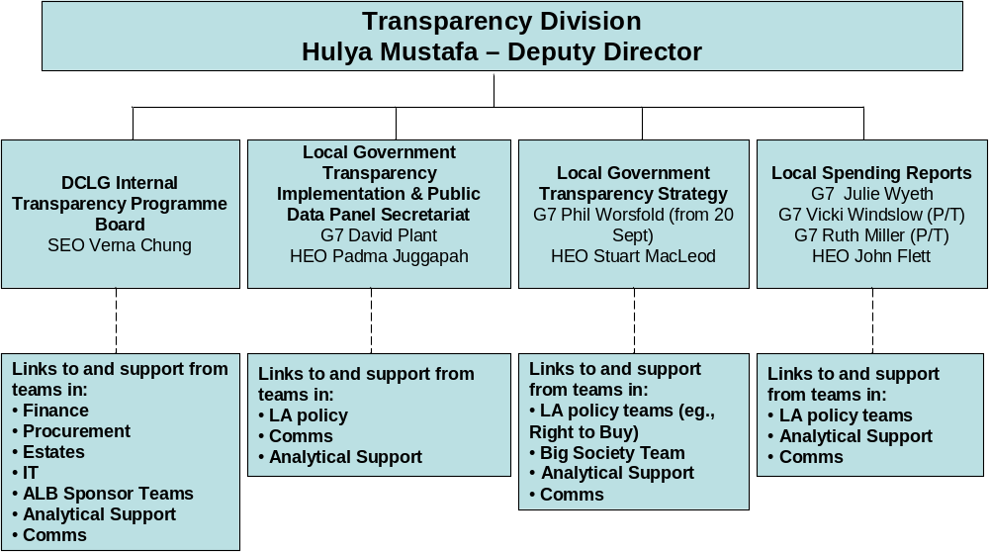

Annex B

Draft Transparency Principles

- Public data policy and practice will be clearly driven by the public and businesses who want and use the data, including what data is released when and in what form – and in addition to the legal Right To Data itself this overriding principle should apply to the implementation of all the other principles.

- Public data will be published in reusable, machine-readable form – publication alone is only part of transparency – the data needs to be reusable, and to make it reusable it needs to be machine-readable. At the moment a lot of Government information is locked into PDFs or other unprocessable formats.

- Public data will be released under the same open licence which enables free reuse, including commercial reuse – all data should be under the same easy to understand licence. Data released under the Freedom of Information Act or the new Right to Data should be automatically released under that licence.

- Public data will be available and easy to find through a single easy to use online access point (data.gov.uk) – the public sector has a myriad of different websites, and search does not work well across them. It’s important to have a well-known single point where people can find the data.

- Public data will be published using open standards, and following relevant recommendations of the World Wide Web Consortium. Open, standardised formats are essential. However to increase reusability and the ability to compare data it also means openness and standardisation of the content as well as the format.

- Public data underlying the Government’s own websites will be published in reusable form for others to use – anything published on Government websites should be available as data for others to reuse. Public bodies should not require people to come to their websites to obtain information.

- Public data will be timely and fine grained – Data will be released as quickly as possible after its collection and in as fine a detail as is possible. Speed may mean that the first release may have inaccuracies; more accurate versions will be released when available.

- Release data quickly, and then re-publish it in linked data form – Linked data standards allow the most powerful and easiest re-use of data. However most existing internal public sector data is not in linked data form. Rather than delay any release of the data, our recommendation is to release it ‘as is’ as soon as possible, and then work to convert it to a better format.

- Public data will be freely available to use in any lawful way – raw public data should be available without registration, although for API-based services a developer key may be needed. Applications should be able to use the data in any lawful way without having to inform or obtain the permission of the public body concerned.

- Public bodies should actively encourage the re-use of their public data – in addition to publishing the data itself, public bodies should provide information and support to enable it to be reused easily and effectively. The Government should also encourage and assist those using public data to share knowledge and applications, and should work with business to help grow new, innovative uses of data and to generate economic benefit.

- Public bodies should maintain and publish inventories of their data holdings – accurate and up-to-date records of data collected and held, including their format, accuracy and availability.

NESTA – is the National Endowment for Science, Technology and the Arts. It’s an independent body with a mission to make the UK more innovative. They invest in early stage companies, inform policy and deliver practical programmes that inspire others to solve the big challenges of the future.
The Young Foundation – brings together insights, innovation and entrepreneurship to meet social needs. It has a track record of over 50 years success with ventures. They work across the UK and internationally carrying out research, influencing policy, creating new organisations and supporting others to do the same, often with imaginative uses of new technology

